Return Shipment Instructions
Australia

Thank you for supporting Bose with the FreeSpace DS 40F recall.
Please ensure your return is package ready for collection prior to organizing the physical return.

Please use the following steps to return recalled product:

- Log onto my.airroad.com.au using:
Username: Recall
Password: DS40F
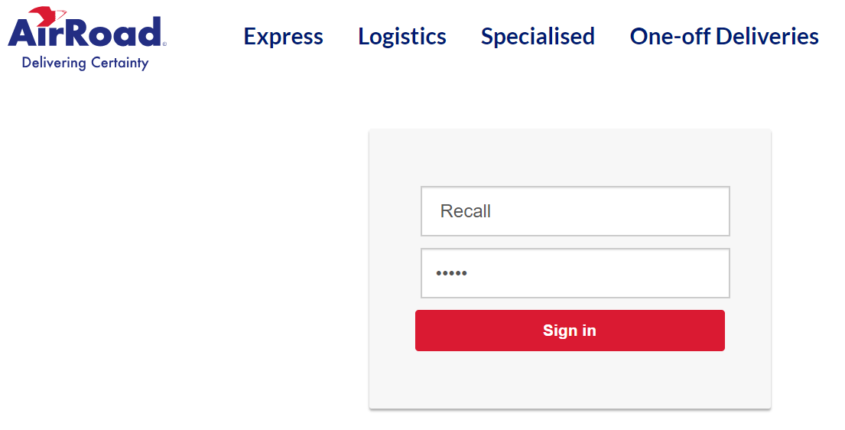

- Click Connote Entry.
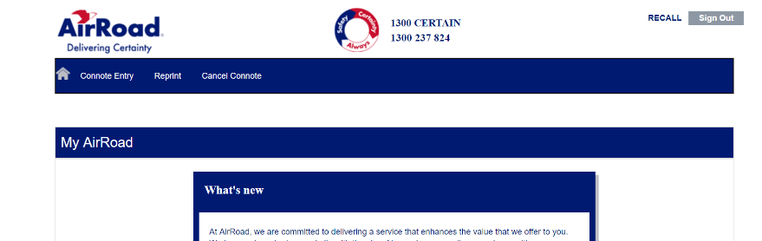

- Under Sender Details, enter your information.
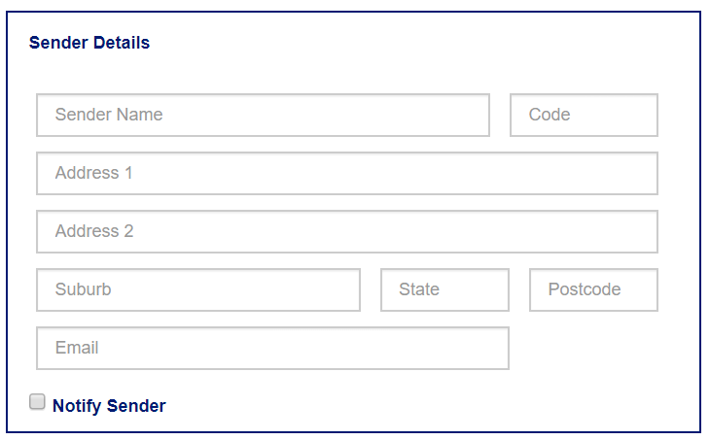

- Under Item Details, list the carton number, weight, pallets (if applicable) and volume.
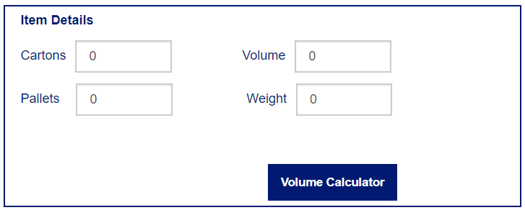

- In the General Instructions field, list any instructions required for transport.

- In the Reference 1 field, enter the order number previously emailed to you in the “DS 40F Recall Shipment Order Confirmation.”

- Click Book Now. This will create a connote label.
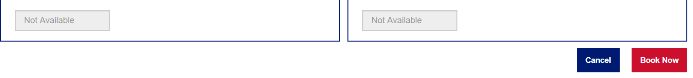

- Print and attach the connote label to the return carton/cartons.

AirRoad will collect the goods on the following day if processed by 2:00 p.m., Sydney time. If processed after 2:00 p.m., the goods will be collected the following day.

Once we receive the product back at our facility, we will process your return and credit your account in approximately two weeks at the previously communicated rate.

If you have any questions or concerns, please visit BoseBMSsafety.com.

Bose Corporation

