Frequently Asked Questions

Recall of DS 40F

How do I know which FreeSpace DS 40F loudspeakers are affected by this recall?
If the FreeSpace DS 40F loudspeaker was manufactured by Bose Professional before August 13, 2018, then it is included in this recall.
If a FreeSpace DS 40F loudspeaker was manufactured by Bose Professional on or after August 13, 2018 or if you are unsure when your loudspeaker was purchased from Bose Professional, follow these steps:

- Determine if the loudspeaker is pendant-mounted.
If the loudspeaker is pendant-mounted, it is NOT included in this recall. A pendant-mounted FreeSpace DS 40F looks like this:
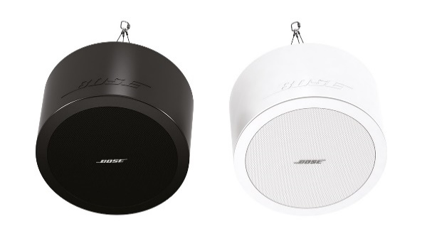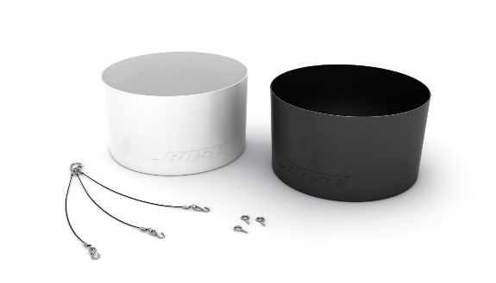
However, if the loudspeaker is in-ceiling/flush-mounted go to Step 2 to determine if the loudspeaker is included in this recall. An in-ceiling/flush-mounted FreeSpace DS 40F looks like this:
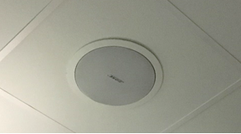

- Find the original paperwork (e.g. Bose Professional order confirmation, shipping confirmation, or invoice) and check for the below product codes.
If you cannot locate the original paperwork, continue to Step 3 to determine if your loudspeaker is included in this recall.
If the paperwork includes one of the following product codes, stop here; your loudspeaker(s) is included in this recall.

Product Codes | Description | Color
321278-0110 | FS DS40F LDSPKR BLK | Black
321278-0120 | FS DS40F LDSPKR 8OHM BLK | Black
321278-0210 | FS DS40F LDSPKR WHT | White
321278-0220 | FS DS40F LDSPKR 8 OHM WHT | White
321278-0130 | FS DS40F LDSPKR BLK | Black
321278-0140 | FS DS40F LDSPKR 8 OHM BLK | Black
321278-0230 | FS DS40F LDSPKR WHT | White
321278-0240 | FS DS40F LDSPKR 8 OHM WHT | White
321278-0250 | FS DS40F VA LDSPKR ASSY, WHT | White
321278-023R | FS DS40F LDSPKR WHT FR | White
321278-024R | FS DS40F LDSPKR 8 OHM WHT FR | White
321278-025R | FS DS40F VA LDSPKR ASSY, WHT FR | White

European Product Codes:
Product Codes | Description | Color
47627 | FS DS40F LDSPKR BLK | Black
47628 | FS DS40F LDSPKR WHT | White
47630 | FS DS40F LDSPKR 8 OHM WHT | White
48451 | FS DS40F LDSPKR BLK | Black
48452 | FS DS40F LDSPKR WHT | White
48453 | FS DS40F LDSPKR 8 OHM WHT | White
60265 | FS DS40F VA LDSPKR ASSY, WHT | White

- If possible, without removing the loudspeaker from its installed location, look at the label on the back of the loudspeaker and locate the date of manufacture (DOM) number. If you cannot safely access the back of the loudspeaker, continue to Step 4 to determine if your loudspeaker is included in this recall. Do NOT remove the loudspeaker from its installed location to look for the DOM number.
The DOM number is the underlined 4-digit number following the Z in the product’s serial number. If the DOM number is 8224 or lower, stop here; your loudspeaker is included in the recall.
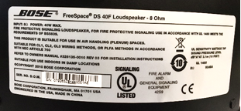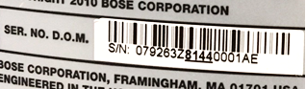
The DOM above, 8144, is lower than 8224, and is therefore included in the recall.

- Have the loudspeaker measured.
IMPORTANT: For safety reasons, this should be done only by a professional installer.

Step 4a: Measure the outer flange diameter.
If the outer flange diameter is less than 300 mm (11.8 in), stop here; the loudspeaker is NOT included in recall.
If the outer flange diameter is 300 mm, proceed to Step 4b.
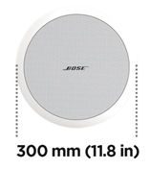
Step 4b: If the outer flange diameter is 300 mm (11.8 in), remove the loudspeaker grille.
If there are two drivers, the loudspeaker is a DS 100F and it is not included.
If there is one driver, measure the driver diameter. As stated above, this should only be done by a professional installer. Be very careful to not damage the grille when removing it.
If the driver diameter is 114 mm (4.5 in), the loudspeaker is included in this recall.
Note: If having a professional take measurements is not possible or if you otherwise cannot determine if the FreeSpace DS 40F loudspeaker is included in the recall using these steps, please contact your Bose Professional reseller.
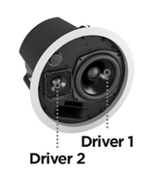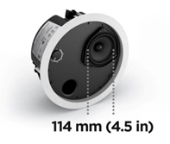

What is the issue with the DS 40F loudspeakers that is causing this recall?
We have found that, due to a design issue, the mounting anchors on DS 40F loudspeakers can break, which could cause the loudspeakers to fall and result in serious injury. This issue has been resolved on all DS 40F loudspeakers manufactured after August 13, 2018.

What is the date range of the loudspeakers that are impacted?
All FreeSpace DS 40F loudspeakers manufactured before August 13, 2018 are being recalled.

How does this affect the product warranty?
All replacement FreeSpace DS 40F loudspeakers include a new warranty. The warranty period for all replacement FreeSpace DS 40F loudspeakers will begin on the date of installation. For information on the FreeSpace DS 40F loudspeaker warranty, go to boseprofessional.com/warranty.

What is the risk of not replacing an affected FreeSpace DS 40F loudspeaker?
If all three anchors on an affected FreeSpace DS 40F unit fail, the unit could fall and result in personal injury or property damage.

Should a FreeSpace DS 40F loudspeaker be replaced even if it is already attached via a safety cable to the ceiling?
Yes. All affected DS 40F loudspeakers must be replaced.

Is the issue affecting the DS 40F present in any other Bose Professional products?
No other Bose Professional products are affected by this issue.

When my FreeSpace DS 40F loudspeaker is removed, how long will it take for a replacement to be installed?
For the most accurate time estimate, please contact your dealer to schedule the replacement. In most cases, removal and replacement will occur during the same visit.

Can I still use rooms that have FreeSpace DS 40F loudspeakers installed?
Until they are removed, keep people and property away from the area beneath the loudspeakers.

When does the replacement need to be completed?
Because we are replacing units to avoid potential safety hazards, all affected loudspeakers should be replaced immediately.

Can an end user replace their own FreeSpace DS 40F?
The FreeSpace DS 40F requires installation by a professional installer. End users who are not professional installers should not attempt to replace the speaker on their own, and instead should contact their Bose Professional dealer.

How are you communicating the DS 40F recall?
Bose Professional is contacting anyone who purchased product from us directly as well as posting a notice on boseprofessional.com. In addition, we are instructing our distributors and resellers to communicate the recall to their customers and are also conducting targeted social media campaigns to reach product owners with whom we would not ordinarily have direct contact.

What is my obligation regarding this issue?
There is a serious potential safety hazard posed by the loudspeakers. In some jurisdictions, it would be a violation of law to disregard this issue and continue using the product.

Will this recall cost me anything?
Your Bose Professional reseller will provide replacement loudspeakers and installation services at no cost to you.

Whom should I contact if I have further questions?
Please contact your Bose Professional reseller.

Installation of Safety Cables

What is the issue with the affected loudspeakers that is causing this field action?
We have found that the mounting components on some of our loudspeakers can degrade and break when exposed to certain substances. Cooking oils and lubricants are the only substances to which the affected loudspeakers are likely to be exposed at levels high enough to degrade their mounting components.

What is the risk of not installing safety cables on the impacted loudspeakers in commercial cooking environments?
If the mounting components on the loudspeaker are exposed to cooking oil or cooking oil fumes they may fail, which could cause the unit to fall and result in personal injury or property damage.

How do I determine if the loudspeaker requires a safety cable?
The loudspeaker requires a safety cable if it is located in the same room as a cooking surface or is exposed to the air from a room with a cooking surface via an HVAC system with an above-ceiling plenum return.

What is an HVAC system with an above-ceiling plenum return?
An HVAC is a system that provides heating and cooling services to a building. An above-ceiling plenum return is a separate space between the structural ceiling and a drop-down ceiling that allows for air circulation for the HVAC as depicted in the image below.
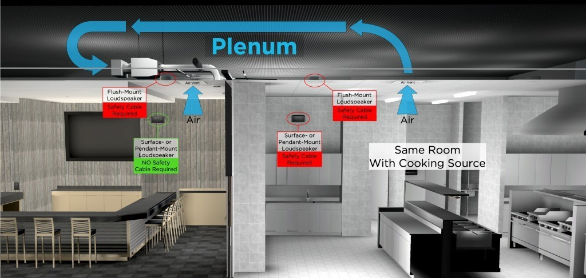

What do you mean by “in the same room”?
You should consider the loudspeaker to be in the same room as the cooking surface unless it is separated from the cooking space by full-height walls, full-height doors and wall openings that normally remain closed.

Which Bose Professional loudspeaker models are affected?
The following Bose Professional loudspeaker models are affected, including all SKU variants of these models, as well as mounting accessories such as brackets and pendant kits.

In-ceiling/Flush-mount Models | Surface-mount Models
EdgeMax EM90 (certain SKUs, see below)  EdgeMax EM180 (certain SKUs, see below)  FreeSpace DS 16F  FreeSpace DS 40F  FreeSpace DS 100F  FreeSpace 3 Flush-Mount Satellites (certain SKUs, see below)  FreeSpace 3 Series II Acoustimass (bass) module (certain SKUs, see below) | FreeSpace DS 16S / 16SE  FreeSpace DS 40SE  FreeSpace DS 100SE

NOTE: Only certain EdgeMax EM90 and EM180, and FreeSpace 3 SKUs are affected:

SKUs still requiring safety cable installation in commercial cooking environments:
778844-0210 (EM90)
777189-0210 (EM180)
40147 (FS3 Flush Bass Module, White)
40148 (FS3 Flush Bass Module, Black)
40149 (FS3 Flush Satellite, White)
40150 (FS3 Flush Satellite, Black)

SKUs not requiring safety cable installation in commercial cooking environments:
778844-0220 (EM90)
777189-0220 (EM180)
843090-0210 (FS3 Flush Bass Module, White)
843090-0110 (FS3 Flush Bass Module, Black)
843091-0210 (FS3 Flush Satellite, White)
843091-0110 (FS3 Flush Satellite, Black)

Why are you making this change?
We are making this change because of Bose Professional’s commitment to continuing to improve the quality of our products and the experience of our customers. The updates to EdgeMax are the result of research into different materials, as well as feedback from customers since the launch of the product.

Why didn’t you make this change before announcing the need for safety cables?
Implementing the use of safety cables for products already installed in commercial cooking environments was the fastest path to preventing a potential safety hazard for our customers and end users.

How can I clean my loudspeakers?
The loudspeaker should only be cleaned/dusted using a dry cloth. The affected loudspeakers must never be exposed to hydrocarbon-based solvents, cleaning solutions, or lubricants, such as WD-40, during or after installation. These materials can also degrade the loudspeaker, and if used on or near the loudspeaker’s mounting components they could cause the mounting components to fail.

How can I be sure that safety cables adequately address this issue?
We have tested the provided safety cable, and if properly installed, it will prevent the loudspeaker from falling.

What if I am unable or unwilling to install safety cables where required?
Remove the loudspeaker and return it to Bose Professional for a refund.

What about loudspeakers in spaces that are not commercial cooking environments?
Although recommended as a precaution in all installations, safety cables are not required on loudspeakers in spaces other than commercial cooking environments unless required by local codes or regulations.

What if my loudspeakers are mounted with a pendant kit?
A pendant-mounted loudspeaker requires a safety cable if it is located in the same room as a cooking surface.

What about products installed in outdoor cooking areas?
While outdoor cooking environments generally have higher levels of ventilation, safety cables must be used for loudspeakers in close proximity to the cooking area or if the loudspeaker will be exposed to cooking oil or cooking oil fumes. If you have any uncertainty about whether a safety cable should be used, we recommend installing it.

Do you know of any other manufacturers that have this issue?
We do not know if any other manufacturers are having this issue. We are working aggressively to resolve the issue with our products. It would not be appropriate for us to speculate on other manufacturers’ products.

I am replacing DS 40F loudspeakers as part of the recall. Do the replacement loudspeakers require safety cables?
Yes, if the DS 40F loudspeaker is installed in a commercial cooking environment then a safety cable is required.

Do DS 40F loudspeakers manufactured after August 13, 2018 require a safety cable?
Yes, if the DS 40F loudspeaker is installed in a commercial cooking environment then a safety cable is required, regardless of when the loudspeaker was manufactured.

If you’ve fixed the design of the DS 40F loudspeaker as part of the recall, then why can’t it be installed without a safety cable?
When exposed to cooking oil or cooking oil fumes, the mounting components on the DS 40F loudspeaker can break, which could cause the speaker to fall and result in serious injury. This issue is not resolved by the new DS 40F design.

Is this issue present in any other Bose Professional products?
No other Bose Professional products are affected by this issue.

I have affected loudspeakers installed in a commercial cooking environment. Before the safety cable is installed, can I still use rooms where the loudspeakers are installed?
Until they are removed, keep people and property away from the area beneath the loudspeakers.

When do the safety cable installations need to be completed?
Because we are taking this action to avoid potential safety hazards, please install safety cables where needed immediately.

Can I install my own safety cables?
The safety cables and the affected loudspeaker require installation by a professional installer. End users who are not professional installers should not attempt to install the safety cable on their own, and instead should contact their Bose Professional dealer.

How are you communicating the issue affecting loudspeakers in commercial cooking environments?
Bose Professional is contacting anyone who purchased product from us directly as well as posting a notice on boseprofessional.com. In addition, we are instructing our distributors and resellers to communicate the recall to their customers and are also conducting targeted social media campaigns to reach product owners with whom we would not ordinarily have direct contact.

What is my obligation regarding this issue?
There is a serious potential safety hazard posed by the loudspeakers. In some jurisdictions, it would be a violation of law to disregard this issue and continue using the product.

Will this recall cost me anything?
Your Bose Professional reseller will provide replacement loudspeakers and installation services at no cost to you.

Whom should I contact if I have further questions?
Please contact your Bose Professional reseller.

