Local Destruction Instructions

Thank you for supporting Bose with the FreeSpace DS 40F recall.

Please use the following steps to receive compensation for installation services.

- Fill out the “Bose DS 40F Recall Destroyed Serial Numbers” file available under “Product Disposition” on BoseBMSsafety.com.

- Do one of the following:

- Certificate of Destruction: Only while using Personal Protective Equipment (PPE), puncture the driver and housing of all products with a hammer (shown here). Deliver these products to a certified scrap recycler and request signed Certificates of Destruction using a witness destruction process.

OR

- Destruction Onsite: Only while using Personal Protective Equipment (PPE), puncture the driver and housing of all products with a hammer (shown here). Take one picture of each destroyed product, clearly showing the damage and serial number. The serial number must be clear enough to read for auditing purposes.
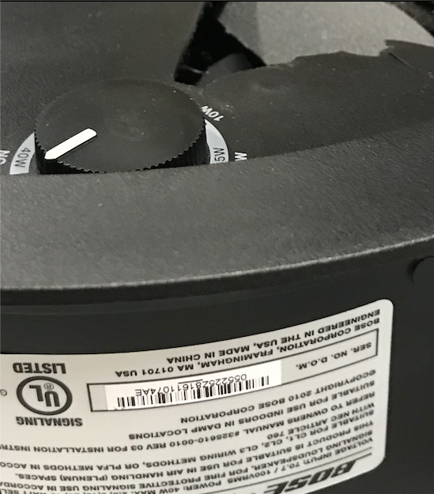

- Attach this information and the “Bose DS 40F Destroyed Serial Numbers” file to an email. In the subject line of the email, enter the first order number entered in the “Bose DS 40F Destroyed Serial Numbers.”

- Send the email to the address listed for your country under “Product Disposition” on BoseBMSSafety.com.

Once these steps are completed you will be compensated at the previously communicated rate.

If you have any questions or concerns, please visit BoseBMSSafety.com.

Bose Corporation

